1 Single Redirection commands > and here also 2. ps-ef

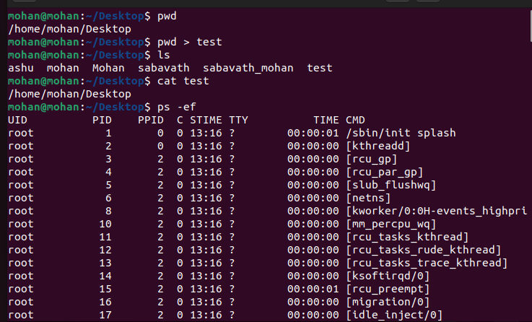

**3 Double Redirection command >>**

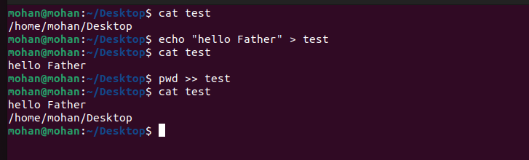

4 Change mode command {chmod} 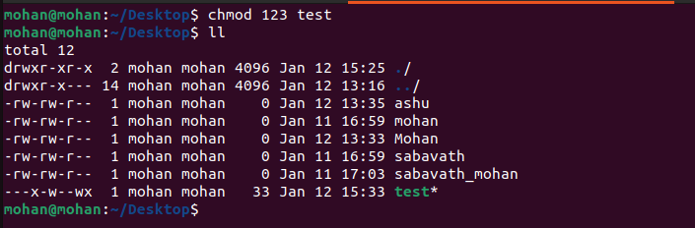

5 Owner , writer and reader rw-rw-x

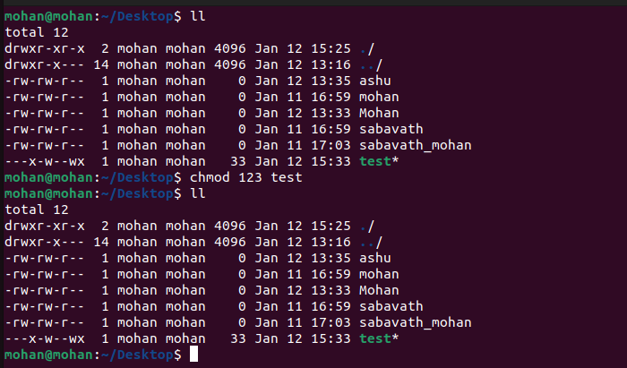

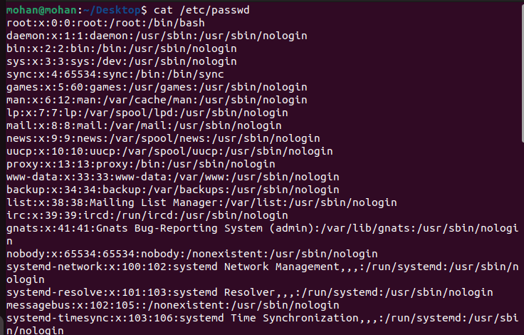

6 No of users are available in the server

7 sudo chown command {changing the owner}

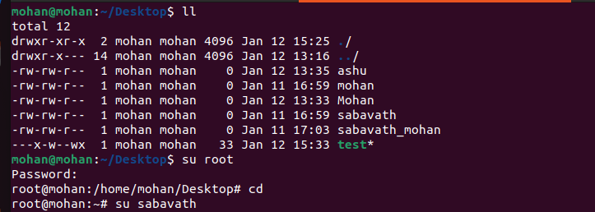

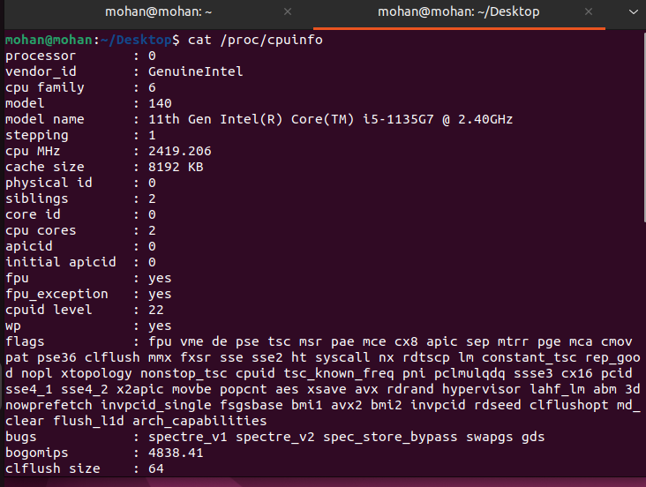 8 Details of cpu command are used is {“cat /proc/cpuinfo”}

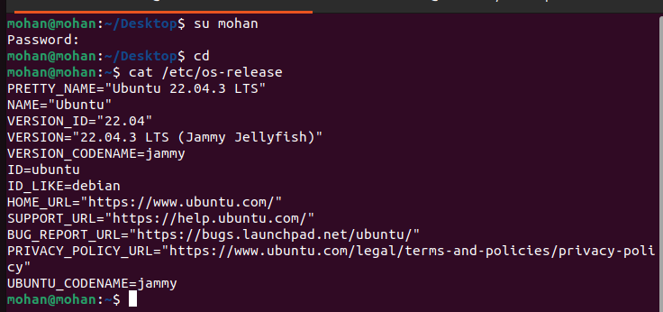9 details of our Operating system (command : cat /etc/os-release)